**EE3070 Technical Training Report**

Important Note: Copying another person's work (even partially) is considered academic dishonesty, and the case will be reported to the University. It may result in disciplinary action against the involved students, including both the one who copied and the original writer.

|  |
| --- |
| **Submission Instructions**   1. The Team Leader must submit the group report via CANVAS Assignment. 2. File format:    * Report in pdf; Filename: TTR-Lx-GPy-SID.pdf  * Lx: lab session number of Team Leader (LB1, LB2, LC1 or L01) * GPy: group number * SID: Team Leader Student ID)   + Program codes for Training I and II attached as appendix.  1. Deadline for submission: Week 7 (before your lab section)    * Students in LB1, LB2 and LC1 (Monday): 3pm on 4th March 2024    * Students in L01 (Tuesday): 11:59am on 5th March 2024   **No late submission will be accepted. Please stay ALERT on CANVAS for any changes however unlikely on updates on submission deadlines.** |

Group No: L02 Gp 4

|  |  |
| --- | --- |
| Student Name | Student ID |
| Team leader: YIP Nim Kong | 57153709 |
| Team Member 1: HE Ka Hung | 57824104 |
| Team member 2: ZHENG Tsz Hin | 57846378 |
| Team member 3: CHAN Cheuk Long | 57206560 |

**30/01/2024/WSC**

**I. Arduino Programming (Based on Technical Training I)**

**Task 1.1 (Answer the 10 questions given in the manual)**

|  |  |
| --- | --- |
| Questions | Your answers |
| 1. What is the operating voltage of Mega 2560 ver 3? | 5V. |
| 1. In maximum, how many digital I/O pins you can assign in Mega 2560 ver 3? | 54 digital I/O pins can assign in Mega 2560 ver 3. |
| 1. Which I/O pins can provide PWM output (give the pin numbers)? | 2 to 13, 44 to 46 pins can provide PWM output. |
| 1. What is the smallest non-zero average voltage that PWM output can provide? | 5V / 256 = 0.01953V. |
| 1. How many pins can be used to read a sensor for which its output is ranged from 0V to 3V? | 16 analog pins (A0-A15) |
| 1. Can we use an I/O pin to directly light up a LED if it needs 2V and 10mA (without using any driving circuit)? | Yes. |
| 1. If you use your Arduino board to read an analog input, what is the possible largest digital value you obtained? | 1023. |
| 1. How many serial communication pairs that Mega 2560 has? | 4. |
| 1. In maximum, how many bytes you can use for your program code? | 258048 bytes. |
| 1. List all the pins that support external interrupts? | D2, D3, D21, D20, D19, D18 |

**Task 1.2**

**Answer questions to get familiar with pin assignment for communications.**

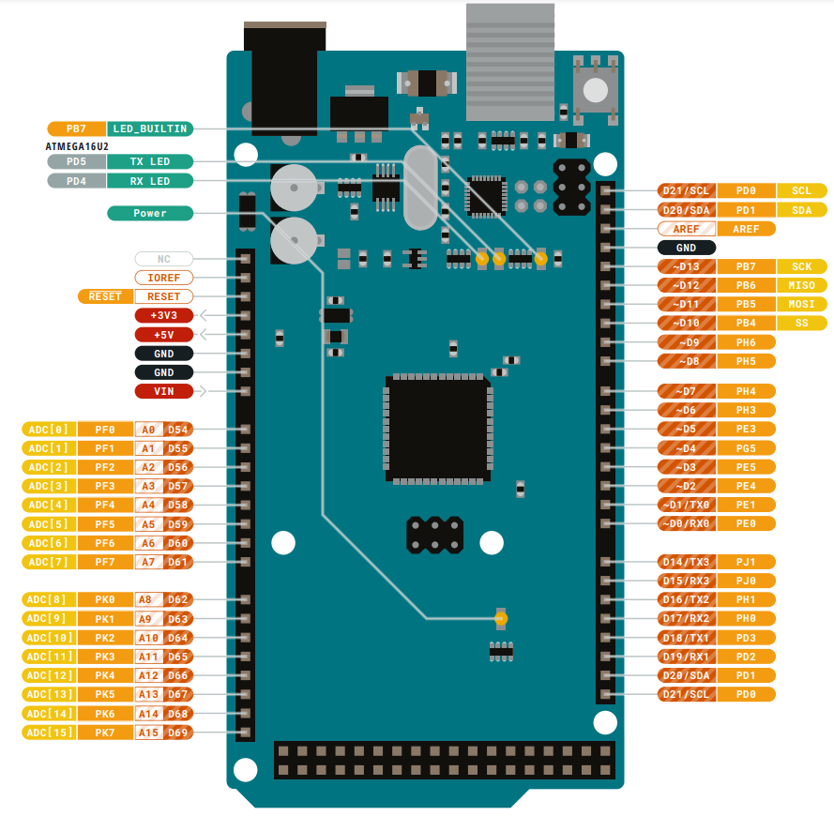



This project will make use of different types of serial communications, namely UART, I2C, and SPI. Please refer to the lecture notes for more information.

1. There are four default UART serial communications. One of them is also used for the Serial monitor. Therefore, do not use that serial if you are using the Serial monitor.Circle the transmitter and receiver pins for that serial port and mark it as UART.
2. I2C communications require 2 pins: one for the clock (SCL) and one for the data (SDA). Circle the default pins assigned for these functions and mark them as I2C.
3. SPI communications use 4 pins: clock (SCK), slave select (SS), master-input-slave-output (MISO), and master-output-slave-input (MOSI). Circle the default pins assigned for these functions and mark them as SPI.

**Task 2 Get Familiar with the project platform**

**Task 2.1**

|  |  |
| --- | --- |
| Modules | The name of the module |
| A | Pressure sensor |
| B | Temperature sensor |
| C | Wi-Fi module |
| D | RGB LED |
| E | RFID Reader |
| F | Relay |
| G | OLED display |
| H | Ultrasonic sensor |
| I | E-Paper |
| J | DC/DC converter |

**Task 2.2**

Explain how the driving circuit works to turn D2 on and off

|  |
| --- |
| * **Transistor Operation**:   + The transistor Q1 is used as a switch. When a control signal from U1 is applied to the base of Q1, it allows current to flow from the collector to the emitter.   + The base-emitter voltage Vbe*Vbe*​ controls the transistor's switching. * **LED Control**:   + The RGB LED has a common anode, meaning all three LEDs share a common positive connection. The individual cathodes are connected to the collector of Q1 through the resistor R1.   + When Q1 is turned on, current flows through R1 and the selected LED(s), causing them to light up. The specific LEDs that light up depend on which of D1, D2, or D3 are connected to the circuit. * **Resistors**:   + **Rb** ensures the base current is sufficient to switch the transistor without drawing too much current from U1.   + **R1** limits the current through the LEDs to prevent damage. |

**Task 3. Programming Tasks**

**Task 3A: Display color with RGB LED**

1. Provide your connection (in simple block diagram)

Arduino

B.LED Input

G.LED Input

R.LED Input

Transistor driving circuit

RGB LED

Jumper box



1. Draw flow chart of your program

1. Provide your program list

|  |
| --- |
|  |

**Task 3B.**

1. Give a description on your function mapping

|  |
| --- |
| * **Pins Setup**: The RGB LED is connected to three pins (redPin, greenPin, bluePin) set as outputs. * **Serial Communication**: Initialized at a baud rate of 115200 for reading commands from the serial monitor.   **Loop**   * **Serial Read**: Continuously checks for available serial data. * **Command Handling**:   + **"red"**: Turns on the red LED, turns off green and blue, and prints "Display on Red color".   + **"green"**: Turns on the green LED, turns off red and blue, and prints "Display on Green color".   + **"blue"**: Turns on the blue LED, turns off red and green, and prints "Display on Blue color".   + **"magneta"**: (Typo: should be "magenta") Turns on red and blue LEDs, turns off green, and prints "Display on Magneta color".   + **"yellow"**: Turns on red and green LEDs, turns off blue, and prints "Display on Yellow color". |

1. Give your program listing

|  |
| --- |
|  |

**Task 3C:**

1. Give a description on your function mapping

|  |
| --- |
| * **Pin Initialization**: The pins for red, green, and blue LEDs are set as outputs. * **Serial Communication**: Starts at a baud rate of 115200. An introductory message is printed to guide the user.   **Loop**   * **Command Reading**: Continuously checks for serial input. It reads a command until a newline character (\n) is detected. * **Command Validation**: Ensures the command is at least 3 characters long, e.g., "R50".   **Command Logic**   * **Extract Color and Brightness**:   + **Color**: The first character indicates the color ('R', 'G', 'B').   + **Brightness**: The subsequent characters represent the brightness level (0-100). * **Brightness Mapping**: Converts the brightness percentage to a PWM value (0-255) using the map function. * **LED Control**:   + Turns off all LEDs initially.   + Sets the brightness for the specified color using analogWrite. |

1. Provide your program listing

|  |
| --- |
|  |

**II. Design Module (Based on Technical Training II)**

Technical Training II: Topic __3__ (Input the topic number)

**II.A Design Task 1.**

|  |
| --- |
| Section 1A. Task description   * To Understand the sample program and run successfully.   + The sample program is to setup the E-ink Epaper and draw the black circle with radius 10units in the position (20,60).   + In first, the E-paper will clear the screen with using fill all the white once. |
| Section 1B. Hardware settings   * Draw a block diagram about the connections and describe the hardware settings   Block Diagram of the connections: |
| Section 1C. Software design   * Line 4 decided the maximum size that we can display in E-paper (#define MAX_HEIGHT(EPD)....) * Line 15 clear the screen to ensure there is no other redundant elements display on the screen * Line 17 displays the circle and decides the circle radius, x-y position. |

**II.B Design Task 2.**

|  |
| --- |
| Section 2A. Task description   * Describe the task in your own words * This task required to define the position of the screen’s center. * Then, display the 100*50 rectangle and the name inside. |
| Section 2B. Hardware settings   * Draw a block diagram about the connections and describe the hardware settings * Note: If the task has the same setup as before, you may just refer to the figure as given in your report. * The Hardware setting is the same compare with task 1. |
| Section 2C. Software design   * In this task, the font file should be included first. (#include <Fonts/FreeMonoBold9pt7b.h>) * To define the position rectangle should start to draw, (display.width/Height() - rectWidth) / 2 used to calculate the position. * Display.drawRect is used to draw the 100*50 rectangle * Then, the cursor should be set to display the name inside the rectangle. * Considering that the full name will display over the range of rectangle, given name “Tsz Hin” is used to display inside the rectangle. |

**II.C Design Task 3.**

|  |
| --- |
| Section 3A. Task description   * Choose a logo and display it onto the E-paper using bitmap, try it once with a paged drawing and once without. |
| Section 3B. Hardware settings   * Draw a block diagram about the connections and describe the hardware settings * Note: If the task has the same setup as before, you may just refer to the figure as given in your report. * The Hardware setting is the same compare with task 1. |
| Section 3C. Software design   * Put the program codes as appendix at the back of report, e.g. Appendix: Task 3 Code. * State at least 3 key points for the design, and explain why they are important (e.g. how you set the pins in software to match with hardware; how to control the I/O; how to set the parameters; …) * First, the const unsigned char logoBitmap[5000]PROGMEM is in-needed to display the logo, PROGMEM can save the memory usage of the Arduino mega. * Then, the array should use tool (example: img2lcd) to convert from image format to c langue. * Finally, the display.drawBitmap is used to display the image. * In the condition about not using drawing page, the iamge woill only show the top part. |

**II.D Advance Design Task 1 (if you have attempted)**

|  |
| --- |
| Section 4A. Task description   * Describe the task in your own words |
| Section 4B. Hardware settings   * Draw a block diagram about the connections and describe the hardware settings * Note: If the task has the same setup as before, you may just refer to the figure as given in your report. |
| Section 4C. Software design and explanation   * Put the program codes as appendix at the back of report, e.g. Appendix: Task 4 Code. * Explain your design (how it can achieve the task) |

**[Add more sections if needed]**

**II.E Discussions**

* Answer the questions in the manual
* Briefly summarize what you learnt

|  |
| --- |
| Question 2: x-y location in top-left is (200-100)/2 and (200-50)/2 = (50,75)  In bottom-right is (150,125)  Question 3: Task1:2kb  Task2:2kb  Task3:26kb  Task3 uses the most memory because it has a array of 200*200 inside. |
| //Appendix: Task 1 |
| //Appendix: Task 2 |
| //Appendix: Task 3 |